Relax and Create
May 7th, 2023

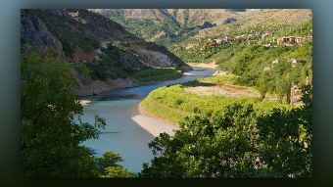
Part 1 of Father Ezekiel’s second 4.23.23 vision:

Wow! For hours and hours, this has been beautiful. It is like a sketch drawing, but it is there, it is real. It seems like there are barriers and a tunnel, and there are layers and layers of angels around, you know, just layers, through this tunnel.

Then it switches to what seems and looks like sand, hm, very much like Egypt. Wow, that is a lot of sand, wow! I have not heard Suez Canal forever, which one is the one that goes through Egypt? It is a shipping lane; it is a manmade shipping lane, ok. And there are men on camels.

The people are using the waterway for everything. Maybe I am not -Maybe I am not wrong about the Suez Canal, but I remember it being mentioned many times. I know about the Panama Canal but the Suez, where is the Suez Canal located? Hm.

And I seem to be now in Belgium, no, Yugoslavia, this is a main thoroughfare that comes up to like a capital. And beyond that, the road seems to end and go either left or right but right there is a-the spires of a large Orthodox church, there will be a cathedral at some point in the future, standing exactly where the White House is, our Capitol, Capital of the United States of America, as it seems to be at this point. So, we pray for them, especially those in the cities, millions of people.

Ok, back in Europe, wow, I guess back in …. Greece? No, it is not Greece. Venice – they are the ones that have the canals and the water lanes and the long boats, the gondolas that they take you on. Hm.

I am back in the Blessed Mother’s little bungalow …

Part 2 of Father Ezekiel’s second 4.23.23 vision:

Mother Clare: He is giving the rivers names.

Father Ezekiel: I am giving the rivers names.

Father Ezekiel: In the northeast of Egypt, where the land is either separated or has been cut through, now they are calling it the Tigris. And the one on the right side of Egypt that has been cut other than separated, they are calling it Euphrates. You can even see it, the names of the rivers, written.

Mother Clare: Wow.

